**Macaroni Cheese**

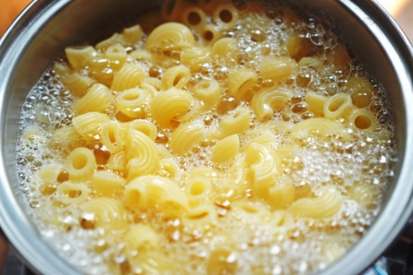

Cook the macaroni

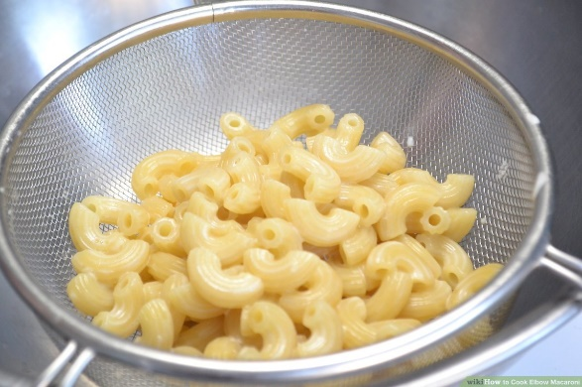

Drain well

[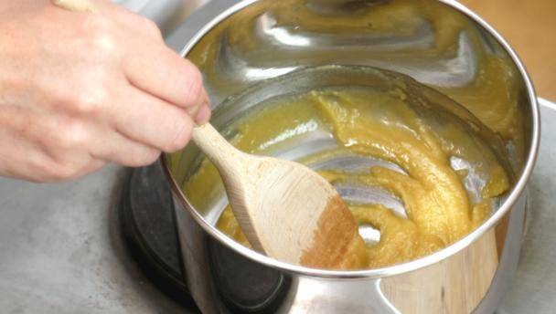](http://www.google.com/url?sa=i&rct=j&q=&esrc=s&source=images&cd=&cad=rja&uact=8&ved=0ahUKEwifssWa5fDXAhWIaRQKHZm6De4QjRwIBw&url=http://www.bbc.co.uk/food/roux&psig=AOvVaw32crTK_okpFFZSC6Z4_sDA&ust=1512491806486338)

Melt the butter and add the flour

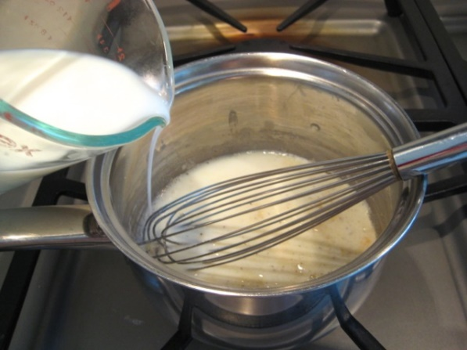

Slowly pour in the milk

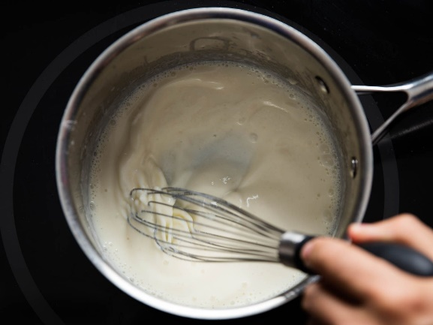

Whisk until smooth

[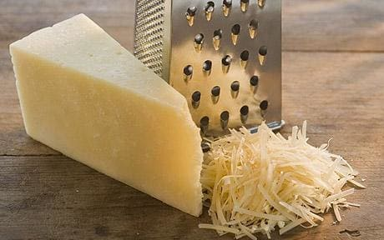](http://www.google.com/url?sa=i&rct=j&q=&esrc=s&source=images&cd=&ved=0ahUKEwidityx2vDXAhUDORQKHUvtAJkQjRwIBw&url=http://www.telegraph.co.uk/news/health/news/4569838/Grating-cheese-cuts-risk-of-heart-disease-says-Food-Standards-Agency.html&psig=AOvVaw30uW0ISrIIoxLpzaKrdBca&ust=1512488901873911)

Add in half the grated cheese

and whisk until smooth

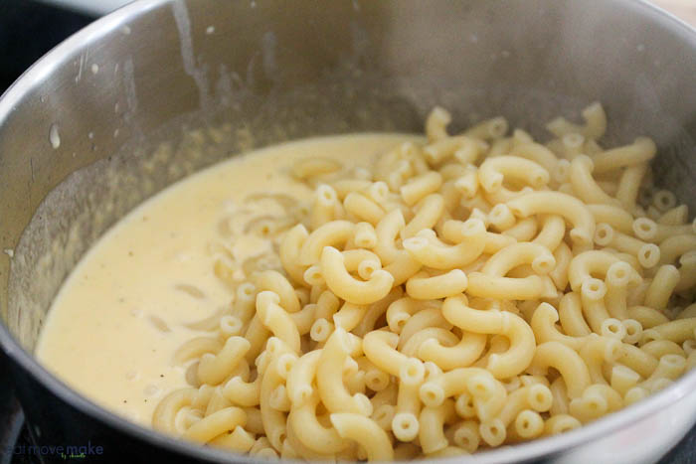

Add in the macaroni pasta

and stir

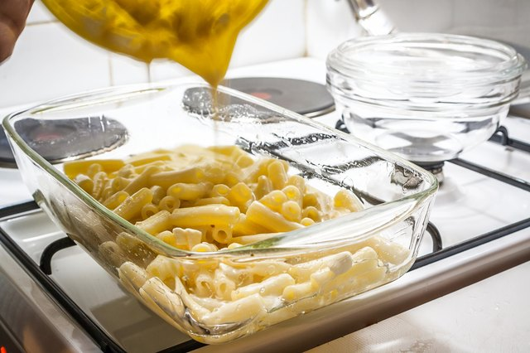

Pour into oven proof dish,

sprinkle with cheese and bake

